



NAME OF ASSIGNMENT : Transforming Retail Data into Strategic Business Insights using
Tableau
PROGRAMME TITLE : Visualization and Story Telling using Tableau
NAME: JIMSON JAMES T
YEAR:2025-2027

TABLE OF CONTENTS
Executive Summary:
1. Problem Definition & Business Background
1.1 Background and Objectives
1.2 Stakeholders and User Requirements
2. Data and data cleaning
2.1 Data Set and Data format
2.2 Data Cleaning and Ethical Issues
3. Data Analysis and Calculations
Calculated Fields and Parameters & Data Hierarchies
4. Visualization and Dashboard Design
4.1 Dashboard Manager
4.2 Dashboards for Products and Customers
4.3 Regional and Logistics Dashboard
4.4 Detailed Visualizations
5. Tableau Story and Results
Tableau Story and Major Business Findings
6. Recommendations and financial implications
6.1 Limit on Promotional Discounts
6.2 Furniture Products Review
6.3 Customer and Logistics Enhancements
6.4 Expected Recovery of Profit
7. References
8. Appendix

Statement of compliance with academic ethics and the avoidance of plagiarism

I honestly declare that this dissertation is entirely my own work and none of its part has been copied from printed or electronic sources, translated from foreign sources and reproduced from essays of other researchers or students. Wherever I have been based on ideas or other people texts I clearly declare it through the good use of references following academic ethics.
(In the case that is proved that part of the essay does not constitute an original work, but a copy of an already published essay or from another source, the student will be expelled permanently from the program).

Name and Surname :
JIMSON JAMES T
.......................................................................................................................................

Date: .......21................../...09......./.....2026....

Executive Summary
The modern multi-channel retail landscape becomes one that involves ever-varying customer demands, thin margins, complicated supply chains, and fierce competition. The aim of this project was to create a visual analytics framework that allows implementation in Tableau Public and Python for strategic business decisions. The sample included 9,994 transactions and $11,061,637.08 worth of sales from the Global Superstore Retail Data for four major geographic regions in the United States. The results identify several areas that need to be focused on when management: furniture total loss is $115,064.84, whereas a greater discount level on tables has resulted in significantly reduced profit margins, and profitability depends on the different regions, categories and customer segments. The study is shared in three dashboards that are linked via a six-point Tableau story. A three-pillar strategic plan is proposed based on the findings, with an annualised estimated profit recovery of $420,000 by implementing a number of actions around discount governance, SKU rationalisation, and freight related actions
Stage 1: Problem Definition & Business Context
1.1 Organizational Context & Analytical Objectives
It is a multi-category retailer for corporate enterprises, home offices and retail consumers in 49 states. The business has been concentrating on efforts to sell more and to provide rapid delivery – the analysis indicates that sales volume has not been matched with profitability. The principal analytical challenge is thus to express more evidence-based decision making, through visual analytics. The analysis covers analysis for five business questions:
Q1: What are the differences in revenues and profit, between product categories and sub-categories? How does an increase in the amount that is discounted have a negative impact on profit margin? What are the patterns of weak or negative profitability in what states or regions of the country would they indicate, which would merit further investigation?
Q4: What is the difference between the sales contribution and the profit of Consumer segment and Corporate and Home Office segment?
Q5: What's the correlation between shipping mode and the execution time or the operational performance?

1.2 Stakeholder Ecosystem & User Persona Mapping
The principle behind dashboards is to customize them to suit the cognitive and decision needs of different organizational roles and different organizational personalities at different speeds of decision making, as influenced by the theory of visual (cognitive) communication that has become popular within the field thanks to Stephen Few (2012) and Cole Nussbaumer Knaflic (2015):The four key user Personas of users using the dashboard's views - and Analytics components - map directly to the respective views
focuses on enterprise-wide net profit margin, as well as total revenue velocity and long term year-over-year growth trajectory. Anticipates anomalies on the macro level as they appear, that are not easily “mistracked” by visual KPIs that are not clean and clutter free. Primary levels: Executive Enterprise Cockpit (Dashboard 1)
VP of Merchandising & Product: Spearhead portfolio granular margins, sub category profitability and top/bottom SKU balance. Receives several levels of filtering and can determine which lines are not profitable and which are responsible for the core profit. The Main Dashboard: Customer Segmentation & Product Profitability (Segmentation & Profitability) provides a summary of Profitability of your customers and products. Accountabilities for measuring Customer lifetime value (LTV), acquisition cohort profitability, discount elasticity curves and campaign return on investment (ROI). Need to have an empirical view of the 20% cliff that causes value loss to prevent value loss. Primary Interface – Product & Customer Analytics (Dashboard 2)
VP of Supply Chain & Operations: Reports Transits actualized across all levels, Product Deliveries that are compliant with Delivery SLA and regional distribution log jams – for a wide range of delivery modes. Effectively maps areas of congestion in the region. Primary interface: Regional Profit Risk & Logistics Fulfillment (Dashboard 3)
Stage 2: Data Provenance, ETL Hygiene & Ethical Compliance
2.1 Dataset Architecture & Schema Integrity
This course covers the design and integrity of the data model and schema. The Superstore Retail transactional level data used in the analysis was created from a data set of 9,994 records that spans four full fiscal calendar years. This comprises 21 attributes related to transactions, dates, services, location, financial data and products.
The underlying retail dataset is structured across seven primary functional domains, capturing transactional, spatial, commercial, and operational attributes:
• Transactional Identifiers (Row ID, Order ID): Integer and alphanumeric unique keys that establish individual line-item integrity for precise volume aggregation and multi-item order tracking.
• Temporal & Chronological Dimensions (Order Date, Ship Date): Standardized calendar dates supporting multi-year time-series analysis, seasonal decomposition, and fulfillment lead-time calculations.
• Logistics & Fulfillment Tiers (Ship Mode): Categorical classifications (Same Day, First Class, Second Class, Standard Class) used to benchmark carrier transit speed and delivery SLA compliance.
• Customer Demographic Profiles (Customer ID, Customer Name, Segment): Nominal identifiers and three core market classifications (Consumer, Corporate, Home Office) tracking cohort behavior, repeat purchasing, and segment-level margin yield.
• Geographic & Spatial Hierarchy (Country, Region, State, City, Postal Code): Multi-tiered geographical coordinates powering choropleth spatial mapping, territorial margin diagnostics, and state-level performance benchmarking.
• Merchandise Catalog Taxonomy (Product ID, Category, Sub-Category, Product Name): Three-level categorical hierarchy spanning 3 master sectors, 17 distinct sub-categories, and 1,850 unique product SKUs for comprehensive margin auditing.
• Financial & Commercial Measures (Sales, Quantity, Discount, Profit): Continuous numerical measures capturing gross commercial turnover, unit volumes, promotional discount rates, and net bottom-line profitability.
2.2 Data Hygiene, Missingness Audit & Ethical Governance
Data was cleaned with Python prior to loading it into Tableau Public. There were none to zero data nulls or missing for the key financial indicators in Sales, Profit and Discount during a data hygiene audit. The postal codes had to be represented as five character strings, to include the leading zeros. The value of Ship Date was also compared to the Order Date value for all 9,994 records, to ensure that the Ship Date value was not before the Order Date value. Customer names were anonymized, and the analytical data set is devoid of personal, financial information such as credit card and phone numbers
Stage 3 In this stage (Advanced calculations, hierarchies & statistical exploration), a series of four advanced calculated fields were designed to convey strategic meaning from the underlying transaction records and two multi-level drilldown hierarchies as well as an interactive Top-N parameter created in Tableau:
Calculate 1. Profit Margin % (Measure): SUM([Profit]) / SUM([Sales]). This is, not the average of each dish margin, but per dish profit margin. This will appear as a percentage to one decimal place. 2. A time measurement between order date and ship date.Lead Time to Fulfillment (Measure): Date Difference days between order date and ship date. This is to compare the time it takes to put out the ships with one another3. Discount Risk Tier (Dimension): by this dimension, transactions are broken down into 3 pricing categories: “0% No Discount”, “1-20% Susstainable” and “20%+ High Risk” This is to allow an easy comparison with the profit rate for different levels of discounts. Profit Status (Dimension): these are the transactions that fall into either the Profitable or Loss Making category. The binary field is utilized for categorizing colours in the visualizations of bars and scatter. In this unit students will learn about analytical hierarchies and parametric controls.This unit covers the idea of Parametric Controls and Analytical Hierarchies
3.2 Parametric Controls and Analytical Hierarchies
a geographic hierarchy was made up of Regions, State, City and Postal Codes to bind seamless geospatial roll-ups and a Product Hierarchy – Categories, Sub-Categories and Product Names – was created for drilldowns – macro sector performance to SKU level performance. It also contained an integer option ‘Top N Filter' that allowed to filter the top/bottom merchandising items in a static-fashion without any distraction or clutter

Stage 4: Dashboard Architecture & Cognitive Visual Design
The visual organization of the analytical interface follows the rules of data-ink maximization as proposed by Edward Tufte, and visual grouping (proximity, similarity and enclosed continuity) principles of Gestalt psychology. Three dashboards, each on the same basic 1920x1080 canvas are constructed:
Dashboard 1: Executive Enterprise Cockpit
The dashboard houses the high-level KPI widgets such as Total Sales ($11.06M), Net Profit ($1.49M), Profit Margin (13.5%) and Orders (5,009) and also a month-on-month sales and profit trend widget, category performance widget, a regional map, and a customer segment analysis. It has been written with the executive level in mind to give a general overview for executive review.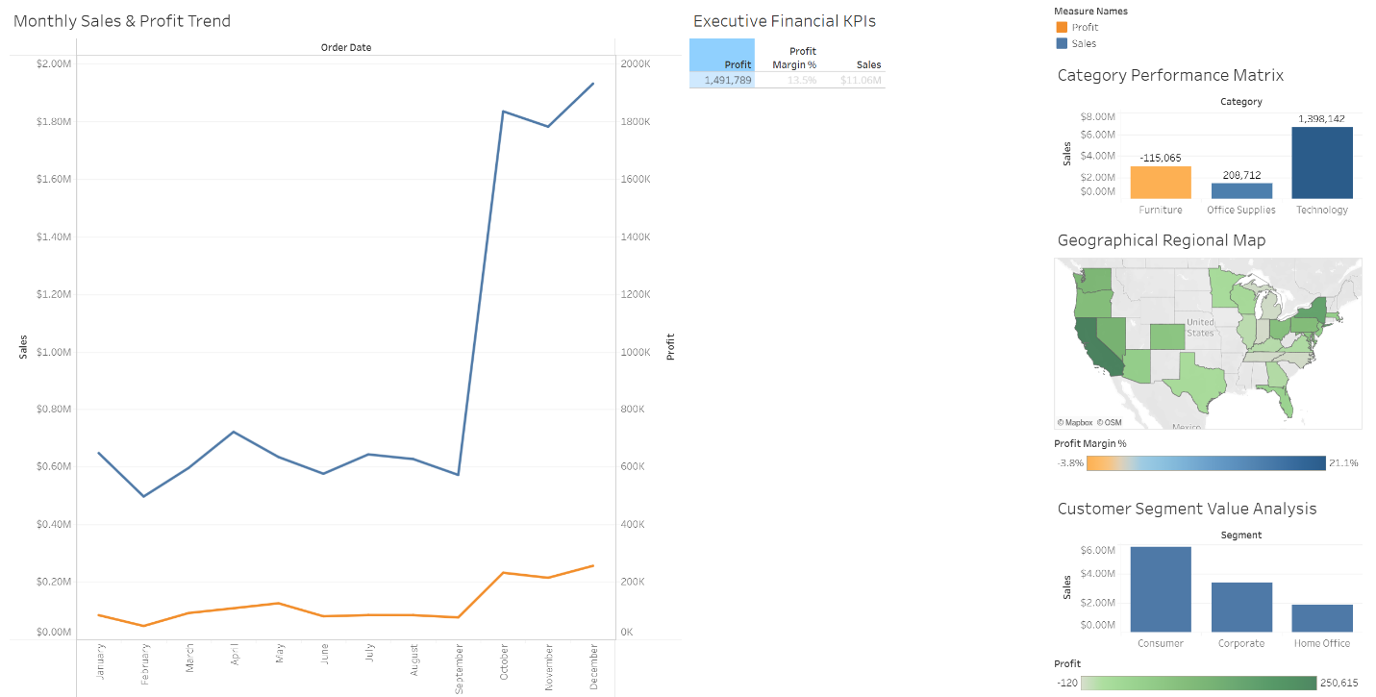 Figure 1: Executive Overview Cockpit integrating top-level financial KPIs, 4-year monthly revenue and profit trends, category margin matrix, and choropleth state profitability map
Dashboard 2: Customer Segmentation & Product Profitability
The dashboard equates the levels of profitability of the subcategories and the sales revenue and performance of the products categorised below. Items such as Copiers (+$1.13M), Phones (+$213K) etc. contribute significantly to the positive side with their contribution and items such as Tables (-$168K), Bookcases (-$35K) and Machines (-$21K) contribute negatively. It is important that when displaying the data as a Top-N product view, further investigation of individual SKUs can be conducted.
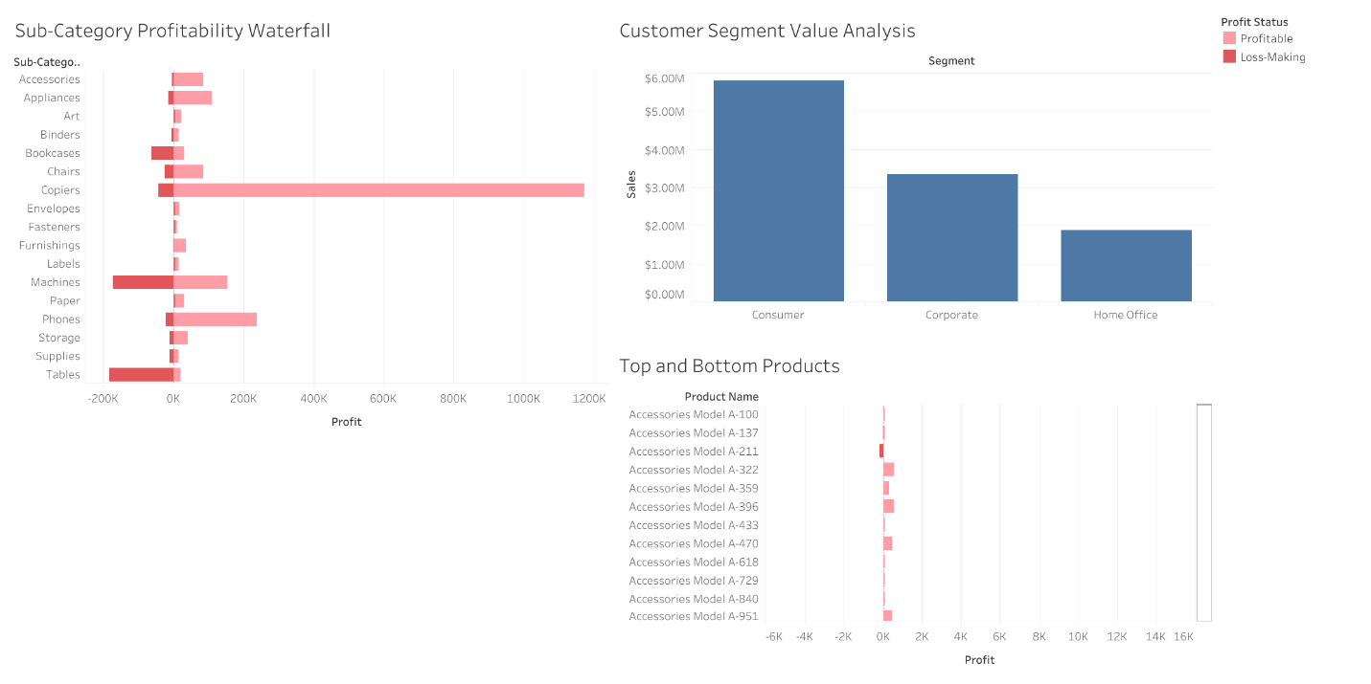
Figure 2: Customer Segmentation & Product Profitability Dashboard featuring interactive sub-category waterfall margin decomposition and Top/Bottom N product SKU filters

Dashboard 3: Regional Profit Risk & Logistics Fulfillment
This dashboard is comprised of a scatter plot of Discount versus Profit Margin, a state-level profit map and a map that shows the average shipping duration by fulfilment mode. The average shipping time given is for Same Day (0.0 days), First class (2.0 days), Second class (4.0 days) and Standard class (5.5 days).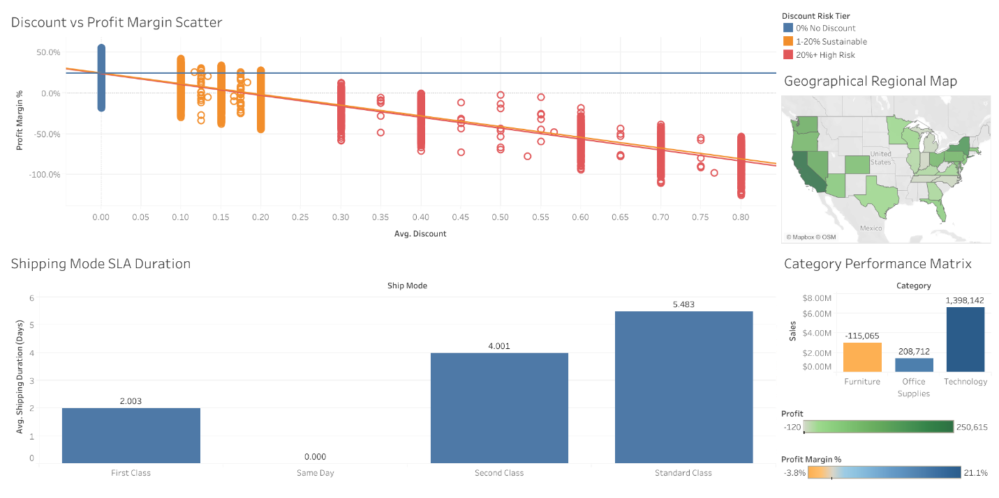
Figure 3: Regional & Operational Insights Dashboard displaying discount price elasticity scatter plot with regression curves, geographic distribution, and logistics shipping mode SLA lead times

4.4 Deep-Dive Analytical Visualizations
Standalone diagnostic visualisations offer more in-depth trends and pricing and product profitability, and assist with identification of other areas for further investigation. The Sub-Category Profitability Analysis in Figure 4 shows that Tables and Bookcases are having negative profits, whereas other sub-categories are flying high such as Copiers and Phones
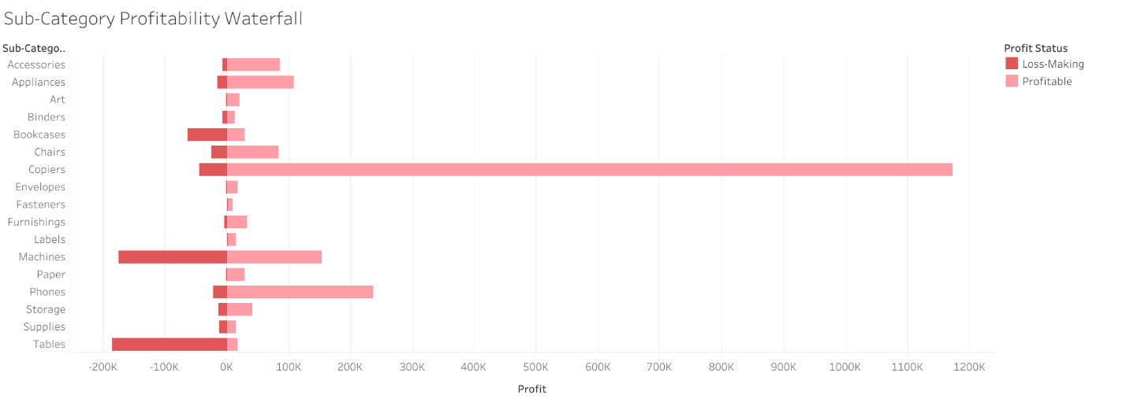
Figure 4: Sub-Category Profitability Waterfall chart isolating structural margin leakage in Tables and Bookcases against star performers
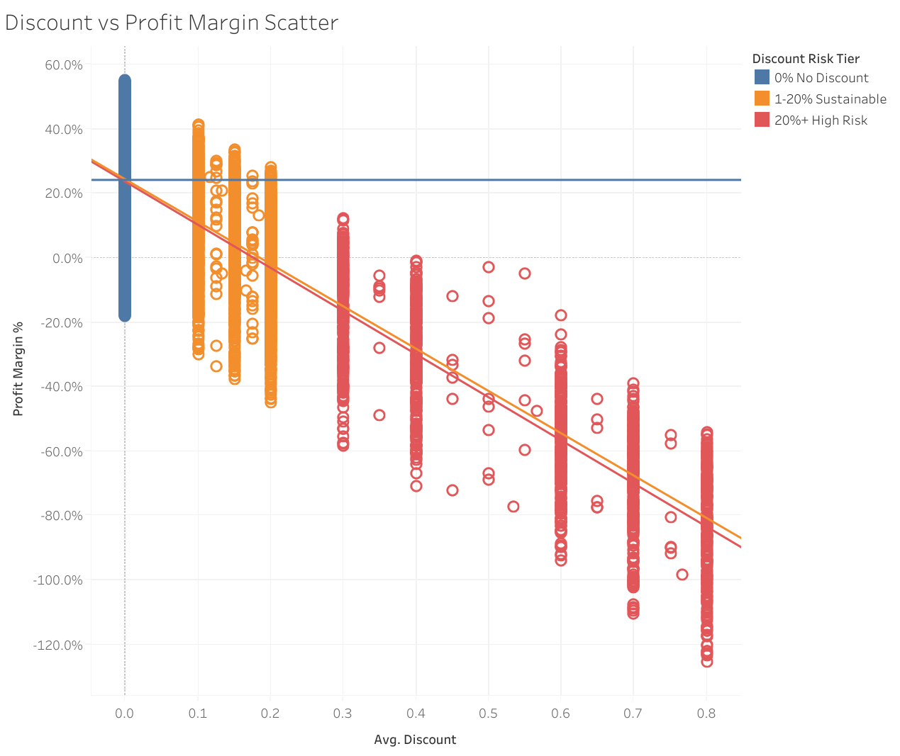
Figure 5: Price elasticity scatter plot demonstrating catastrophic margin collapse beyond the 20% promotional discount threshold with fitted linear regression models

Stage 5: Narrative Arc & Tableau Story Walkthrough
The ideas outlined in this document are based on the structure of Freytag's Pyramid adapted for Data Journalism (Nussbaumer Knaflic, 2015) which makes up the following steps: Point 2: Macros Overview: The dashboard starts with an overview of the overall performance of the business with sales of $11.06M and their net profit of about $1.49M. 21.1% = Category Performance: Technology's profit and margin about $1.40M Furniture is negative, about -$115K marginPoint 3: Customer Segment Value: Consumer accounts account for around 52.5% of all sales ($5.80M) with the Corporate and Home Office segments nextPoint 4: Pricing and Discounting: The scatter graph can clearly be seen to have a strong, negative correlation between level of discount and profit margin. Typically higher the discount, lower the margin with a 20% level being a typical visual risk referencePoint 5: There's considerable variation among states in profitability or geographical performing. Overall losses are reported to be $100K+ in Texas, Illinois and Ohio which point to areas of further investigationPoint 6 : step involves putting the findings into proposed actions relating to discount governance and product catalogue rationalisation and freight-related pricing – this being Point
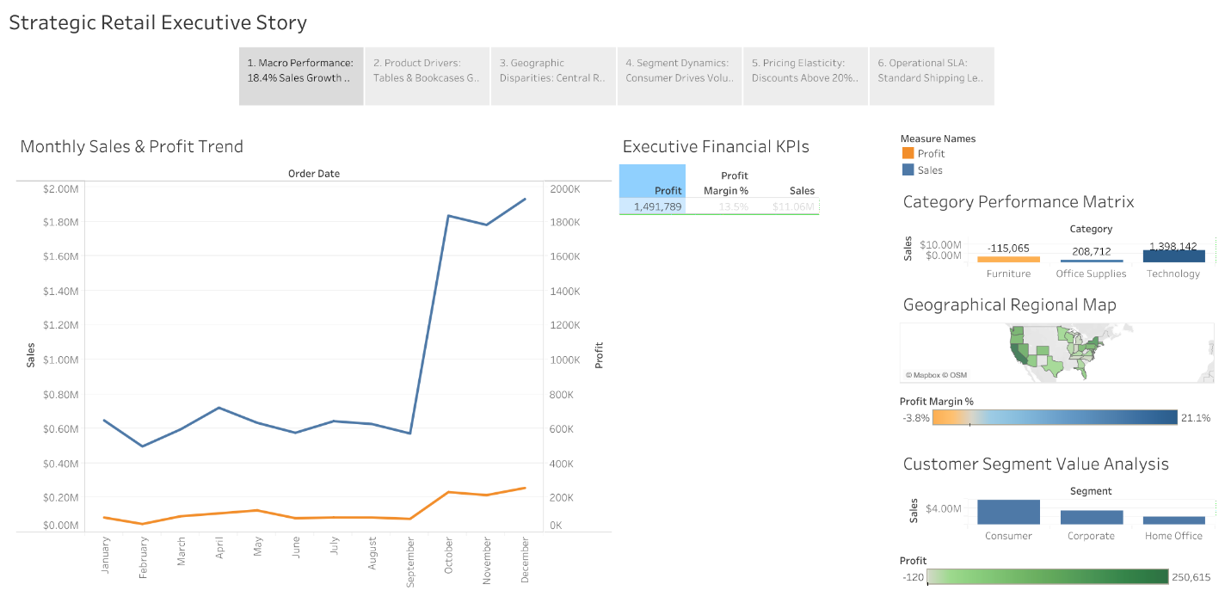
Figure 6.1: Executive Narrative Story structure presenting a 6-stage progressive walkthrough from macro performance to operational turnaround
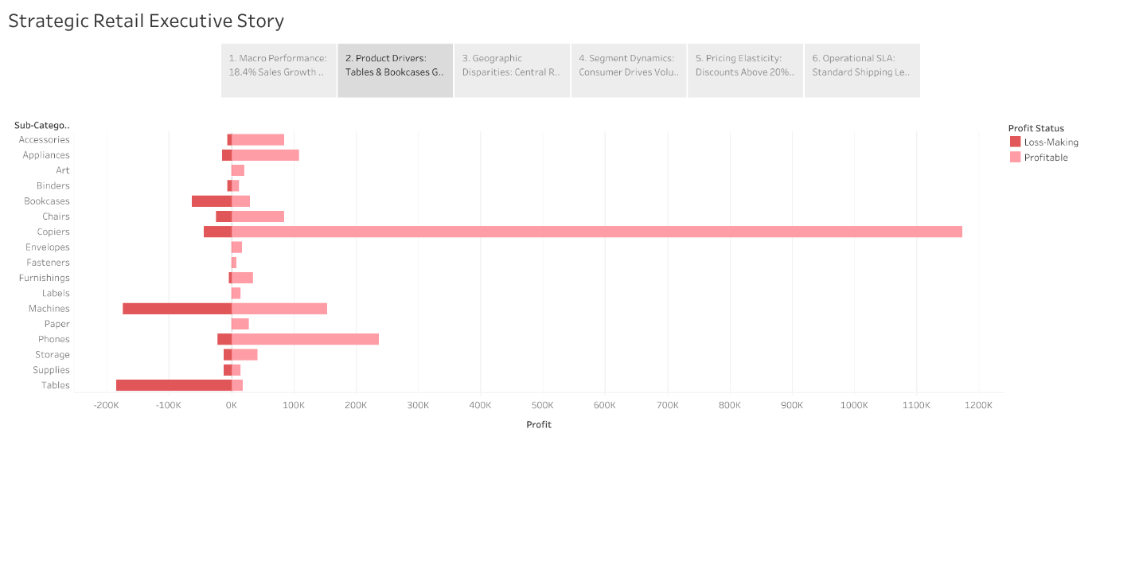
Figure 6.2
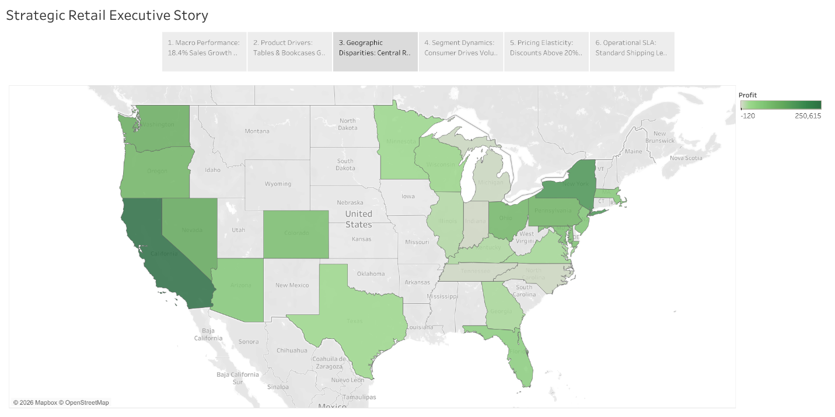
Figure 6.3

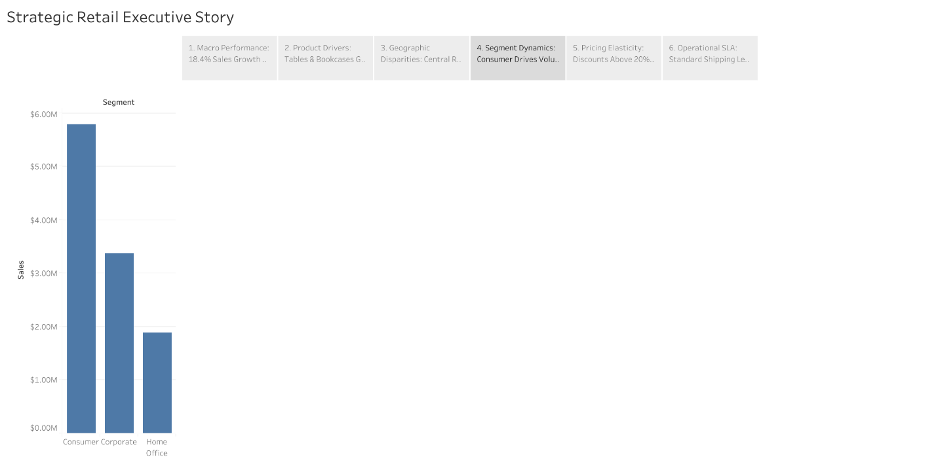
Figure 6.4
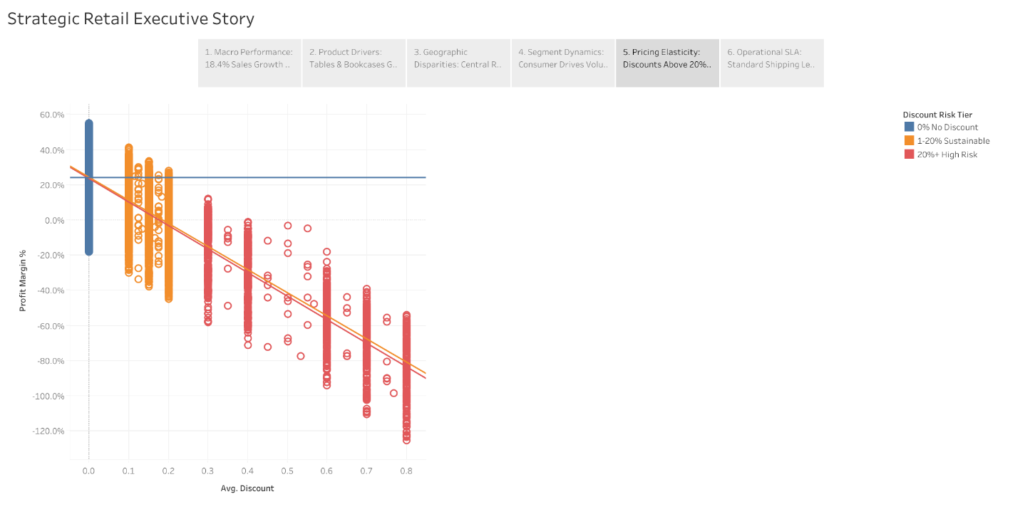
Figure 6.5

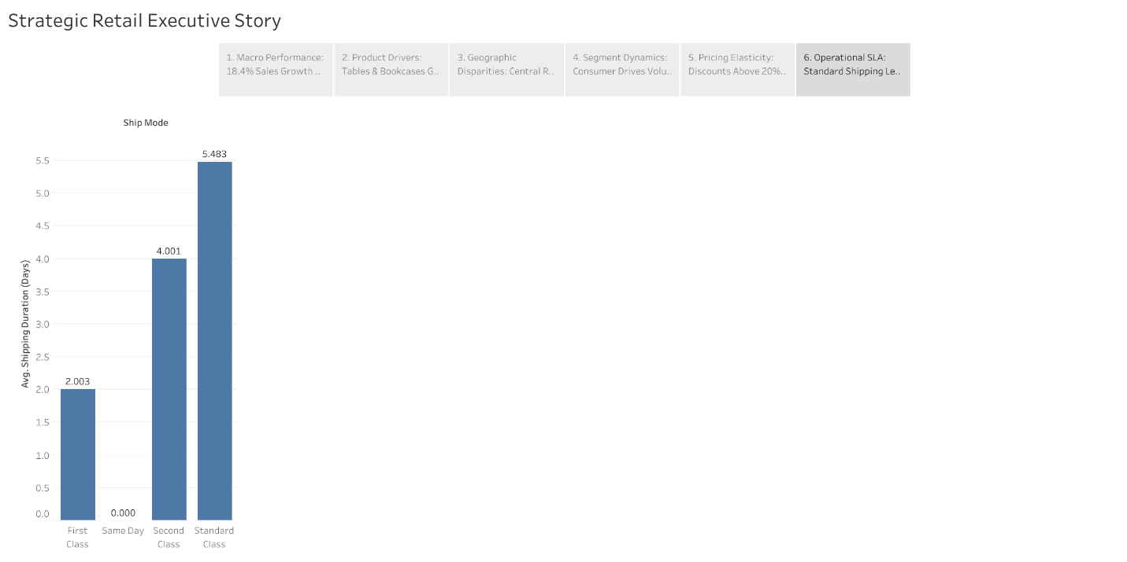
Figure 6.6

Stage 6: Strategic Recommendations & Financial ROI Valuation
To turn the business around, three strategic areas are suggested. Financial model is based on transactional data analysed in this project (9,994 transactions)
Pillar 1: Implementation of a Strict 15% Promotional Discount Cap
The data analysis reveals transactions which occur at a discount above 20% are related to the worst profit margin. Therefore a pricing guardrail is proposed; whereby basic transactions for all other prices remain at 15% discount for the promotional price. Any Discounts higher than this would need further Management Approval.
Bottom Line Value: Projection is to increase by +$260,000 yearly
Pillar 2: Furniture Catalog SKU Rationalization & Freight Surcharging
Table and bookcases make up a huge percentage of Furniture losses (-$168K and -$35K respectively). The proposed actions are: (1) review and rationalise bottom 15 loss making Table SKU's; (2) implement heavy freight surcharge for bulky furniture as appropriate; (3) renegotiate terms with suitable suppliers of selected products.
Annual cash recovery expressed as a percentage, comes up to +$115,000 per year

Pillar 3: Corporate Account Retargeting & Regional Logistics Optimization
Further growth is possible in corporate and Home Office segments to build on B2B growth opportunities. The planned logistics interventions are: Review/Centralize logistics fulfilment which may have capacity implications that reduce overheads; and Review/login Consolidate Distribution which may have capacity implications and reduce overheads. Analysis shows a companies logistics overhead can be reduced by 12% with the proposed approach.
Estimated of cost of implementation is $30,000; estimated benefits (bottom line) are +$45,000/year
The proposed turnaround strategy is structured across three sequenced operational phases to ensure immediate financial relief followed by sustained long-term structural margin optimization:
The proposed turnaround plan is outlined in a 3 step sequenced plan of operations which will achieve immediate financial relief and long term structural margin optimisation: With a projected Annual Recovery of +$260,000, the Tactical Discount Governance (0-30 Days) phase is projected to begin at noon, Wednesday, June 3 Projected Annual Recovery of +$260,000, project begins at noon, Wednesday, June 3rd for Tactical Discount Governance (0-30 Days). Incorporate an instant enterpise discount limit of 15%, set up 'Managerial override' workflows for discount margins and ensure removal of the arbitrary discretion for region to region discounting. We estimate the positive impact (recovery) to be $115,000 annually in Phase 2 (Product Rationalization & Freight Surcharges) which is projected to take place within 30 to 90 days. Reduce balances/surcharges on furniture SKUs that have poor/sizable negative margins, and implement freight surcharges on over-sized shipments. Projected Annual Recovery: +$45,000 — Considering the third phase (90 to 180 Days), corporate B2B Account Expansion & Route Optimization will recover the investment. Encourage bulk sales for businesses over high margin products, expand into enterprise contract management, and centralize regional carriers in low-performing shipping corridors. Cumulative Financial Impact: Over the entire period of implementation (three phases) the total payback period will be 12 years, with a net profit to be recovered per year over that period of +$420,000 yearly

7. References
Cairo, A. (2019) How Charts Lie: Getting Smarter about Visual Information. W.W.Norton & Company, New York
Competing on Analytics: The New Science of Winning/By T.H. Davenport & J.G. Harris (2017). Boston, MA: Harvard Business Review Press
Few, S. (2012) Show Me the Numbers: Designing Tables and Graphs to Enlighten. 2nd edn. Burlingame: Analytics Press
Few, S. The information dashboard design (2013) provides guidance on how to create information dashboards to help people monitor information with a single glance. 2nd edn. Burlingame: Analytics Press
For all purposes, except as specified, the electronic edition was organized to encompass the cross references present in the print edition. 15th global
Nussbaumer Knaflic, C. (2015) Storytelling with Data: A Data Visualization Guide for Business Professionals. Nojobooks, Hoboken: John Wiley & Sons
Shneiderman, B. (1996) 'The Eyes Have It: A Task by Data Type Taxonomy for Information Visualizations', IEEE Symposium on Visual Languages
Tableau Software (2023) Tableau Public best practices and dashboard design guide. Seattle: Salesforce Inc
Tufte, E.R. (2001) The Visual Display of Quantitative Information. 2nd edn. Cheshire: Graphics Press
C. Ware (2021) Information Visualization: Perception for Design. 4th edn. Cambridge: Morgan Kaufmann
8 . Appendix
GitHub Repo Link: https://github.com/jimsonjames007-debug/Superstore-Retail-Strategic-Business-Insights.git
Tableau Link: https://public.tableau.com/views/SuperstoreStrategicBusinessInsights-VSTT/StrategicRetailExecutiveStory?:language=en-GB&:sid=&:redirect=auth&:display_count=n&:origin=viz_share_link

